**Workbook 2 # TurtleSim**

1. roscore
2. rosenode list
3. rostopic list
4. rosrun turtle (press tab twice) See if turtle is installed
5. rosrun turtlesim turtlesim_node
6. Now in new terminal, rostopic list
7. Type rostopic list
8. Type rostopic -h
9. Type rostopic info /turtle1/cmd_vel
10. Type rostopic info /turtle1/pose
11. Type rostopic type /turtle1/cmd_vel
12. Type rosmsg show geometry_msgs/Twist
13. Type rostopic pub -1 /turtle1/cmd_vel geometry_msgs/Twist --‘[2.0,0.0,0.0]’ ‘[0.0,0.0,1.8]’
14. Type rostopic hz /turtle1/pose
15. Telemetry with keyboard : rosrun tutlesim turtle_teleop_key
16. Run rosrun rqt_graph rqt_graph
17. Type rostopic type turtle1/cmd_vel | rosmsg show

**Workbook 3 # Turtlebot in Gazebo**

1. Type gazebo
2. Type roslaunch turtlebot_gazebo turtlebot_world.launch

**Workbook 4 # Custom 2 wheeled robot**

1. Type roslaunch ros_training robot_rviz.launch model:=urdf_robot1.urdf
2. Type roslaunch ros_training robot_rviz.launch model:=urdf_robot2.urdf
3. Get the controller now Type roslaunch ros_training robot_rviz.launch model:=urdf_robot1.urdf gui:=True
4. Type urdf_to_graphiz urdf_robot2.urdf

**Workbook 4 # Control the Turtlebot2 with keyboard**

1. Type roslaunch turtlebot_gazebo turtlebot_world.launch
2. For keyboard teleop type roslaunch turtlebot_teleop keyboard_teleop.launch

Other commands -

1. rosservice call gazebo/get_model_state '{model_name: mobile_base}’
2. rostopic list | grep mobile_base
3. rostopic type /mobile_base/commands/velocity
4. rostopic pub -r 10 mobile_base/commands/velocity \geometry_msgs/Twist '{linear: {x: 0.3}}’

**Workbook 5 # Configure your Joystick in Linux**

1. Follow these steps and commands

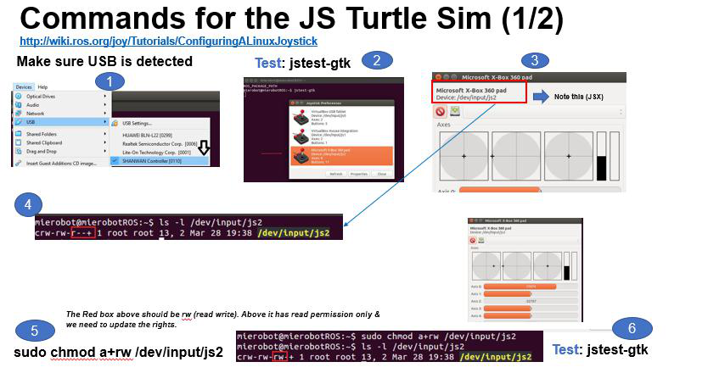

**Workbook 6 # Use Joystick to control TurtleSim**

